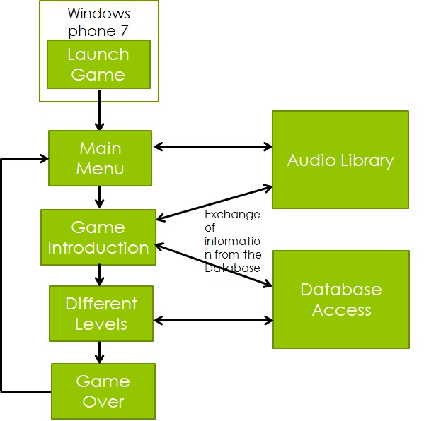

When the user clicks on the application icon, this game is launched in the windows phone.

When the game is launched the first page or the menu page of the game is displayed.

The menu page consists of two buttons, PLAY and EXIT.

At the click of the play button, the introduction of the game is started. Here, the characters of the game is introduced, and tells the user the storyline of the game.

After the introduction of the game different levels of the game is started. When the user loses all the attempts or if the time-out occurs, the user is displayed with a “game over”. Where the game control is navigated to the Menu page.

Throughout the game the images for the game are accessed from the database, and the audio player agent is linked to the game to play the audio at the background.